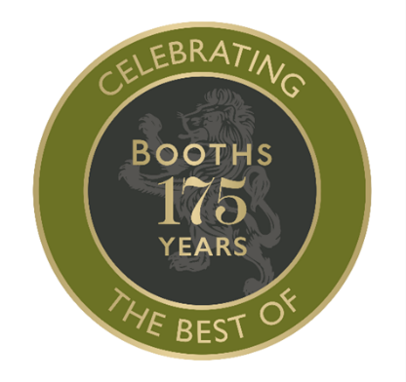
The Booths Accelerator
Application

The aim of The Booths Accelerator is to help grow, develop, and sustain a food & drinks business of the future.
This is your chance to pitch your idea or product to Booths and tell us about your aspirations and plans for your business. Do share where you might need assistance from Booths and be honest around the challenges you face. This information will be treated confidentially and shared with a panel of buyer and executives at Booths.
The purpose of the initiative is to encourage new and emerging food & drinks businesses to flourish, and while only one business will receive the ultimate support package, you may be invited to present your product for a listing at Booths, receive valuable feedback and advice on how to get your product to market. You have nothing to lose and much to gain.

Alongside answering the questions outlined in this from, you are welcome to supply a presentation of supporting material for your application but do ensure that the file size easily emailable and no more than 10mb.

We can’t wait to hear more about your plans.

Submitting your entry
Applications are open until the 31st of August
Email your completed entry and supporting material to: accelerator@booths.co.uk

Full Name

Company Name

Name of Product/Idea/Initiative

Email Address:
Website address:
Twitter:
Instagram:
Facebook:
Linked-In:
Other social media (please specify):
Contact phone number

Your Background (300 word limit)

(Education/Work/Skills/Achievements/Interests/Benevolence - This is your chance to tell us about YOU)

Tell us about your Business/Product/Initiative/Idea? (300-word limit)

Think about:

- What is the essence of your product or idea?
- What gap/problem is it filling/solving ? (Why have you developed/created it?)
- When did development begin ? (if you have started)
- How have you progressed to date?
- Who is involved in your business?
- Where is your business based and where is your physical target market?

Let us know a little more about your product idea:-

- Product Details (Description, pack size, retail price etc)
- Is your / Are your product(s) Food or Drink
- Which temperature regime/category Ambient Packaged, Chilled Packaged, Meat/Fish, Fruit/Veg/Salad, Frozen, Bakery, Licensed, Other (please specify)
- How and where is your product(s) produced or manufactured?
- Do you produce, use a 3rd manufacturer or use contract packing ?
- Do you have any technical specifications such as SALSA, BRC etc
Executive Summary (500 word limit)
The really important section - this is your chance to sell yourself and your Business/Product/Idea and give clear, comprehensive and compelling reasons why Booths should support your business throughout 2023

Things to think about in your submission
- What is the size of the prize ? (size of commercial opportunity)
- Is the product or brand expandable into other categories and markets ?
- What qualities/skills do you possess to give confidence for success ?

Outline your plan for business growth or bringing this to market? (500 words)

Things to cover in this section:
What sales development and marketing plans do you have (including your achievements to date?)
Who are your customers and who are your key future prospects?
Are you looking for financial investment/cash support and if so, how much and what would the funds be used for?

What are your barriers to success and how would the support from Booths help to transform your business? (200 word limit)

Where do you require support from Booths? (200 word limit)
Is it packaging, design advice, manufacturing/packing, product development/technical, sales, back-office administration, funding, mentorship, and other obstacles to success or where you need assistance?

Tell us about your business ethos and what if important to your emerging brand (200 word limit)
This might cover any or all aspects of the ESG (Environment, Social, Governance) agenda. In short how will you ensure your business is a ‘good’ business.

